**DSA Final Project Report**

**Pizza Management System**

**GROUP MEMBERS**

Muaaz Bin Aleem SP21-BCS-049

Mohid Anwar SP21-BCS-047

**SUBMITTED TO:**

Maam Saneeha Aamir

Object Oriented Programming - CSC24

**Table of Contents**

Description 3

Data Structures 3

Doubly Customer Linked List 3

Graph (Sectors) 4

Feedback Stack 5

Cancellation Queue 5

Functionalities 6

Starting Menu 6

Customer 6

Ordering 6

Display of Menu 6

Display details of Customer 6

Give Feedback 6

Cancel an Order 6

Go Back to Main Meu 6

Admin 6

Display All 6

Deliver a Bunch of Orders 7

Delete Customer 7

Display All Customers 7

Look at Pending Feedbacks 7

Look at Canceled Order Queue 7

Go Back to Main Meu 7

# Description

Our code is a Pizza Shop Management System which allows the user to place orders to specific locations. The system stores all of the Customers and their respective orders accordingly. The customer can give feedback and cancel orders as well.

The system is mainly divided into two parts: Admin and User. All accounts are password protected.

# Data Structures

## Doubly Customer Linked List

Each customer node has its specific data and has a previous and next pointer. The specific data includes:

* Name
* Password
* Unique ID
* Next and Previous pointers
* First Order pointer

Each customer has its respective order list attached to it. The order specific data includes:

* Order ID
* Item Name
* Quantity
* Price
* Order Destination
* Distance to Destination
* Next Pointer

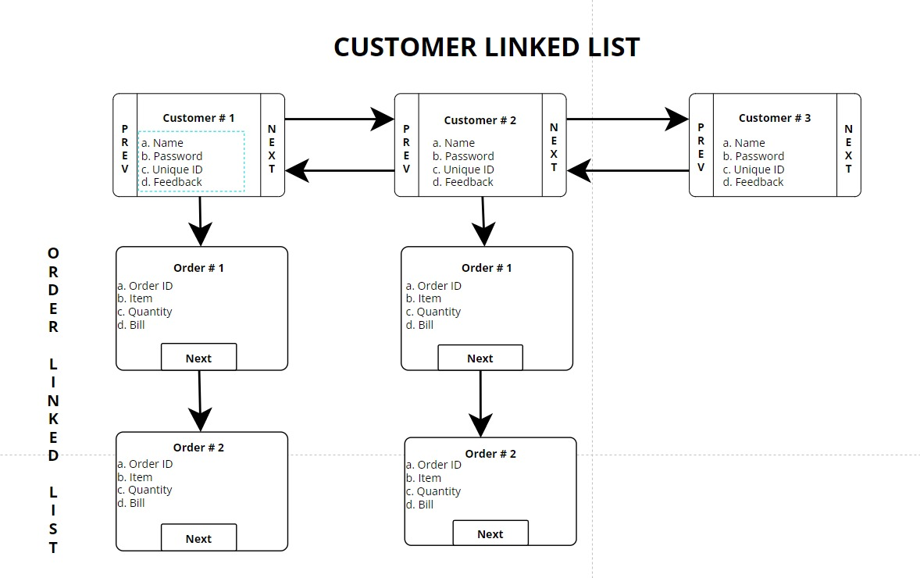

## Graph (Sectors)

The Graph structure contains sectors and its respective adjacency matrix contains the distance to each sector. The sectors are stored in a Vertex data Structure. The Figure below shows the map used for the program (PH is the restaurant):

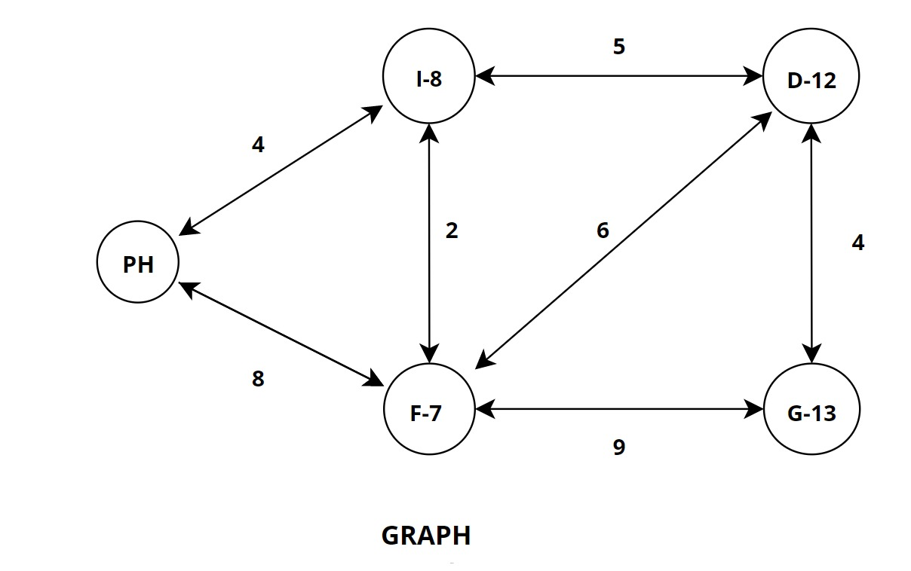

## Feedback Stack

The Feedback Stack stores user feedback. Whenever feedback is given it is pushed into stack. When admin wants to look at the feedback they are pushed out of the stack (just like the notification bar on the phone).

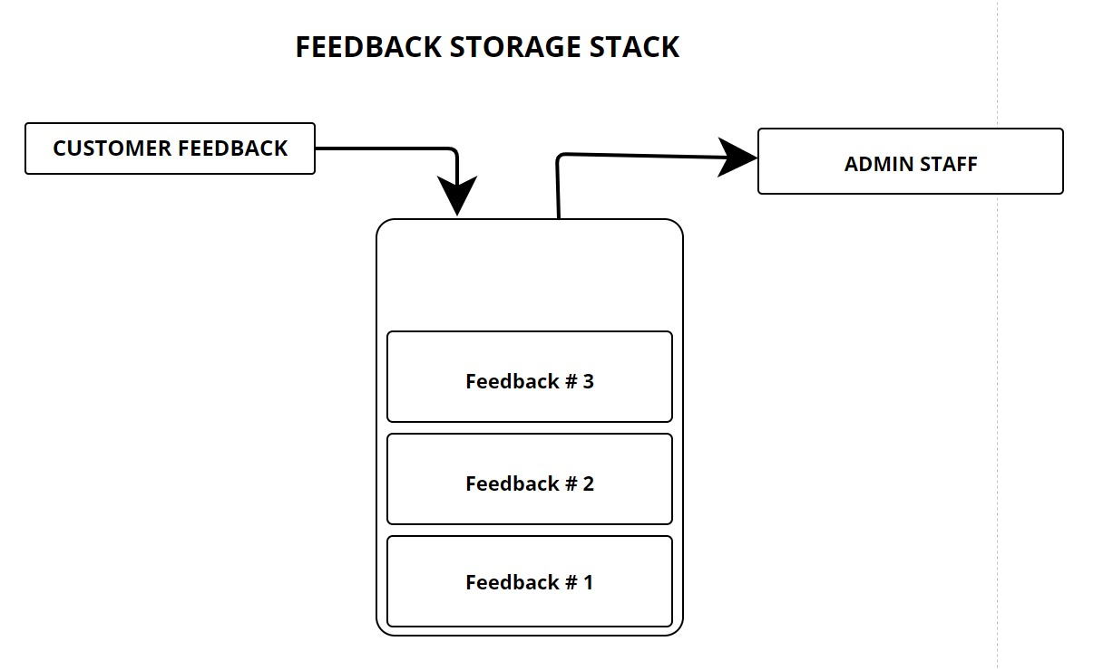

## Cancellation Queue

Whenever a user decides to cancel an order. The Order node is pushed into a queue and the admin can look at cancelled orders whenever he wants to (Just like Notifications).

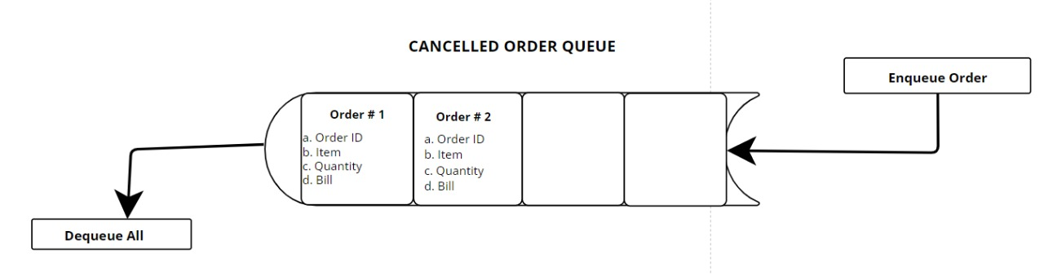

# Functionalities

## Starting Menu

The initial menu determines whether the user of the program is an Admin or a customer. It also has the option to exit the program. After entering proper credentials the user is logged in. The user can also signup as a customer.

## Customer

The Customer has the following functionalities:

### Ordering

The Order details are acquired from the user. After that the destination sector is provided and the single source shortest path is calculated using dijkstra Algorithm. Lastly the new order’s details are displayed.

A copy of the order placed is also added into a Priority Queue so it can be delivered later on.

### Display of Menu

This function will display all the menu items and respective prices accordingly.

### Display details of Customer

This function displays the logged in customer details and the orders that the customer has placed.

### Give Feedback

The feedback function gets the feedback and additional comments. The feedback is pushed into a stack.

### Cancel an Order

The user enters Order Id and that order is removed from the doubly list structure. Then it is added to the cancelled Order Queue

### Go Back to Main Meu

Takes user back to Starting Menu Screen

## Admin

The Admin has the following functionalities:

### Display All

This function displays all customers with their respective orders

### Deliver a Bunch of Orders

This function will deliver all pending Orders

### Delete Customer

This function searches for the customer using the customer ID and then deletes it from the doubly list.

### Display All Customers

This function displays the customers who have signed up without their respective orders.

### Look at Pending Feedbacks

Displays and pops stack containing feedback

### Look at Canceled Order Queue

Displays and removes cancelled orders from Order Queue

### Go Back to Main Meu

Takes user back to Starting Menu Screen